**Aim:** Recording an action of logging into LinkedIn account and create a post.

**Objectives:** To automate LinkedIn post.

**Tools used:** Automation Anywhere

**Concept:** Understanding of the capture action and its properties and the Browser action.

**Problem Statement:** Create a bot that Login in to your LinkedIn profile and create a post.

**Steps:**

Go to Automation Anywhere website create a Bot and named it LinkedlnPost.

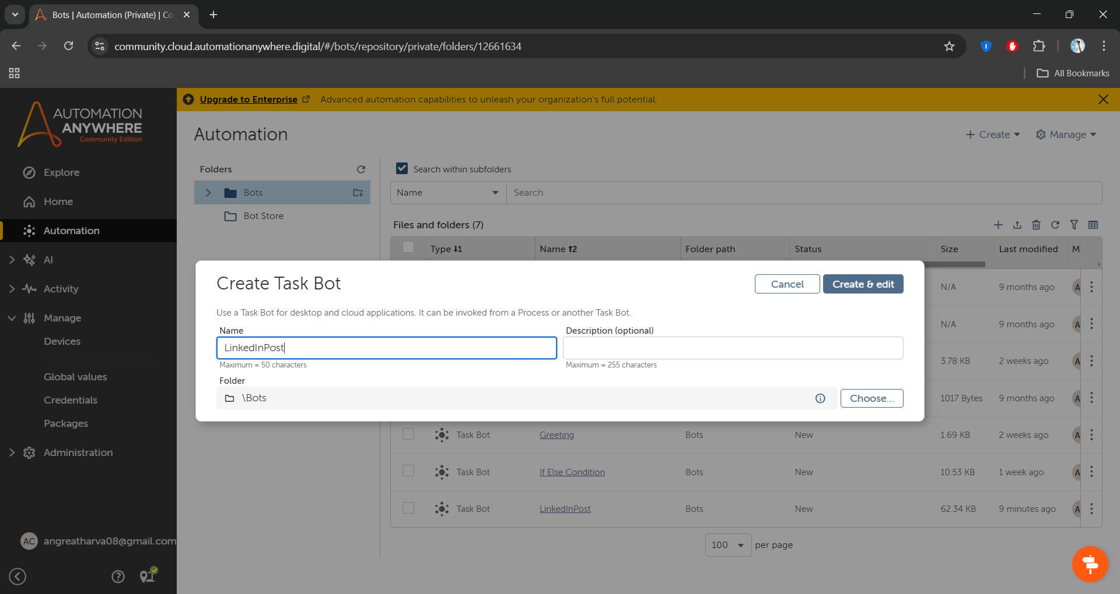

Now go to action tab and add browser open action and see on the right-hand side add browser to open and also provide link

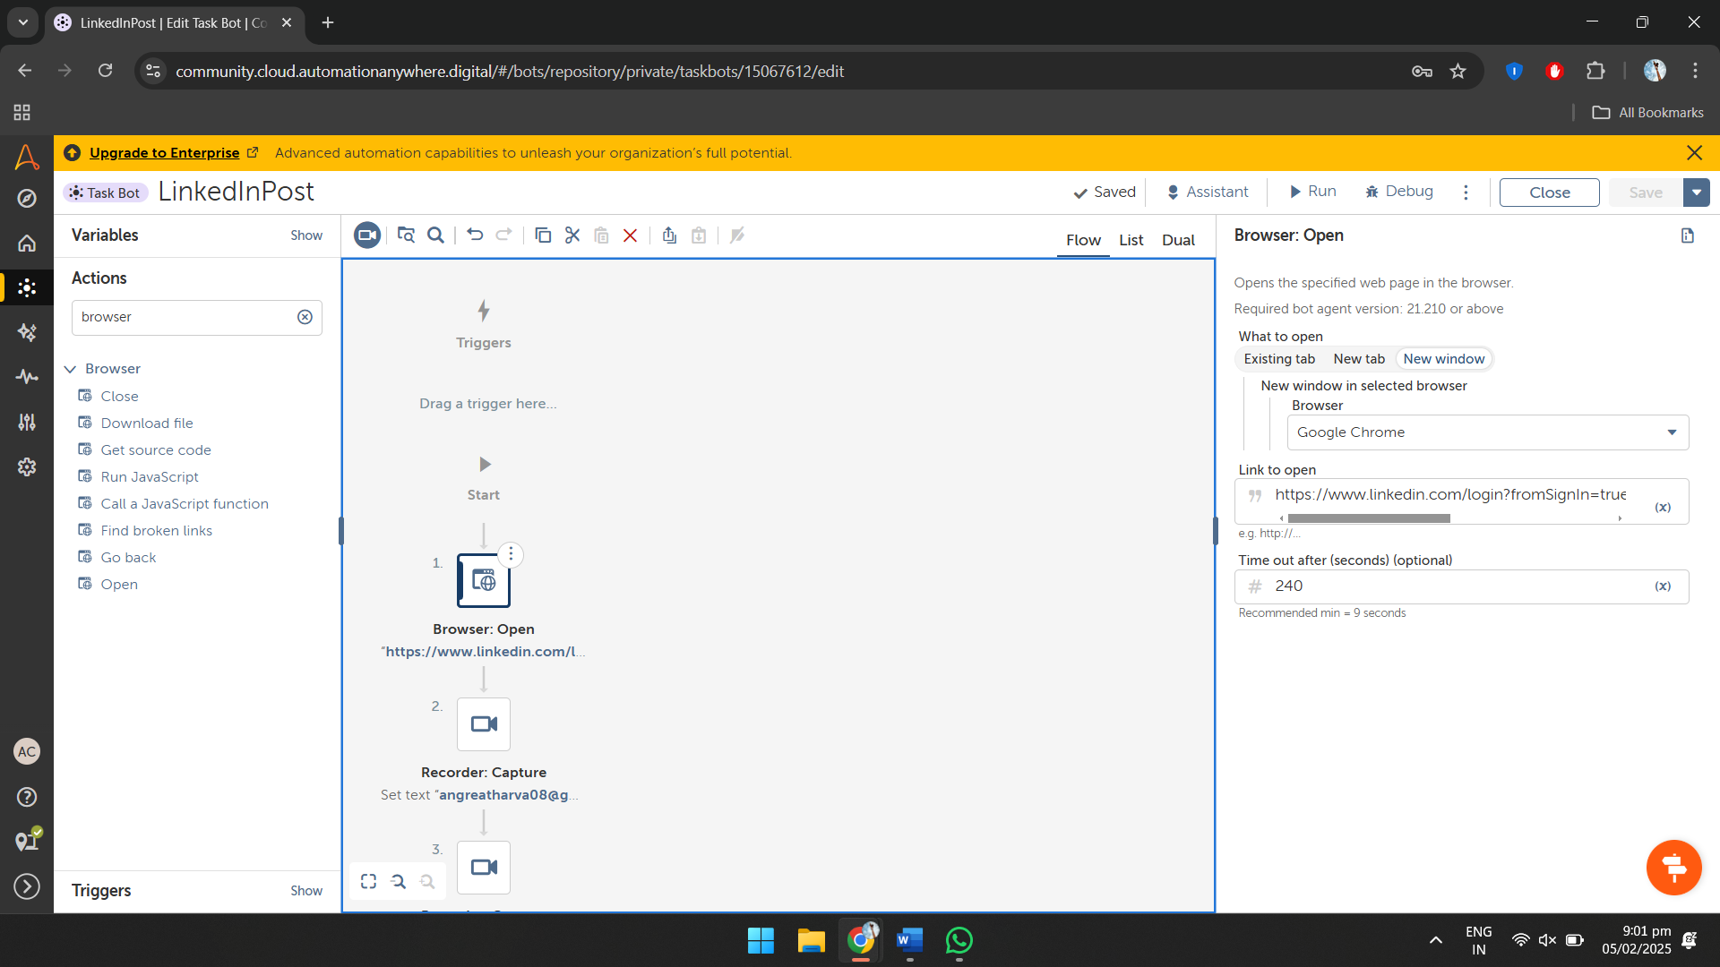

Add Recorder capture action from the action to capture the enter email field

1. change the property add link of sign-in page a
2. capture the email text.
3. In drop down select set text and type your email

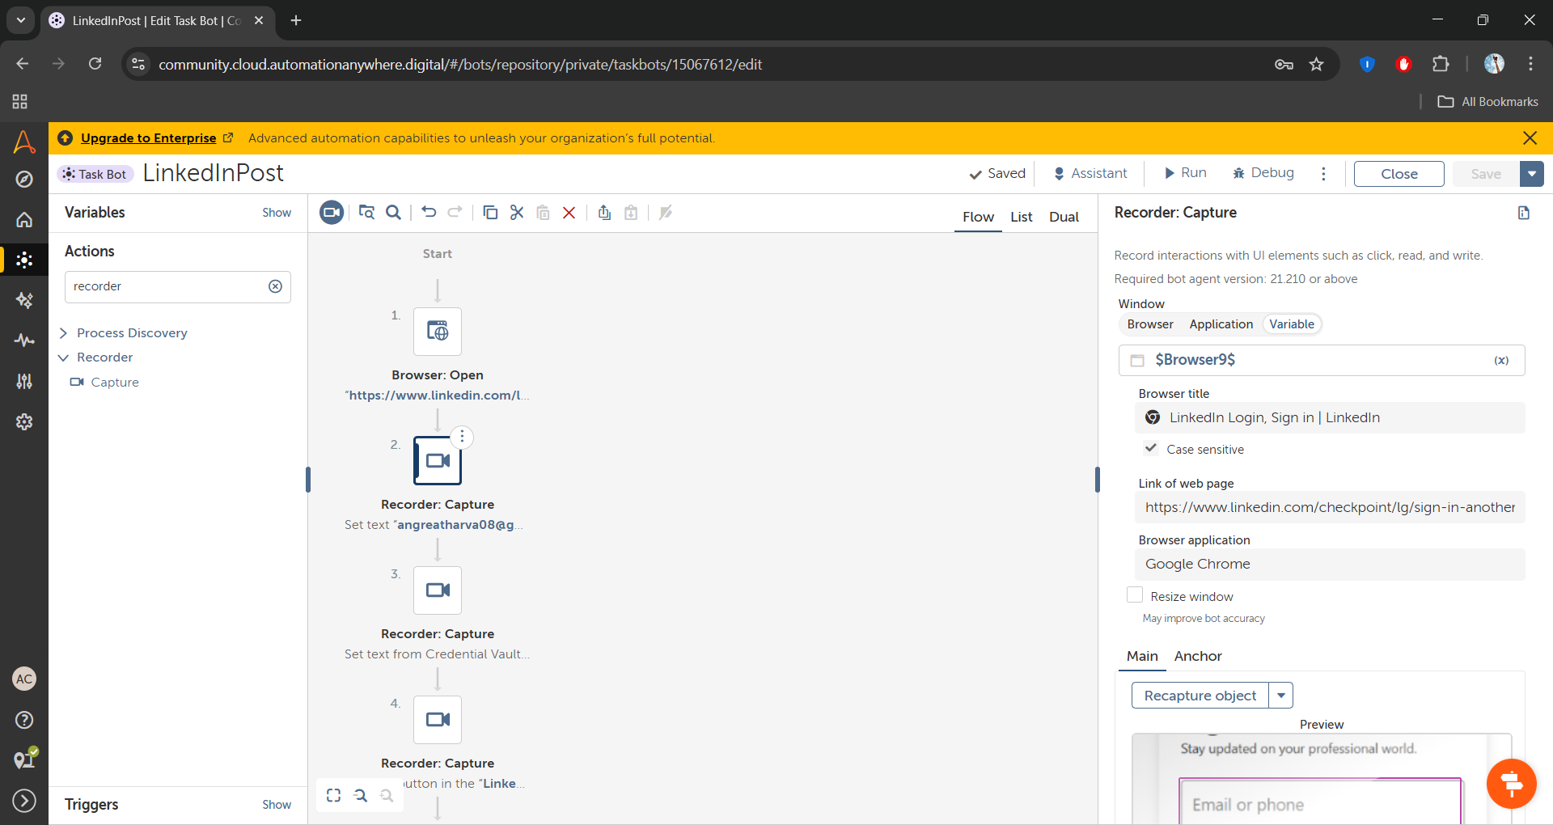

Now add recorder capture action to capture password field from the action tab.

1. Go to credential and create credential and name it Linkedln_Password_Credential and give attribute name to the Credential_Password and select standard and In value field type your password.

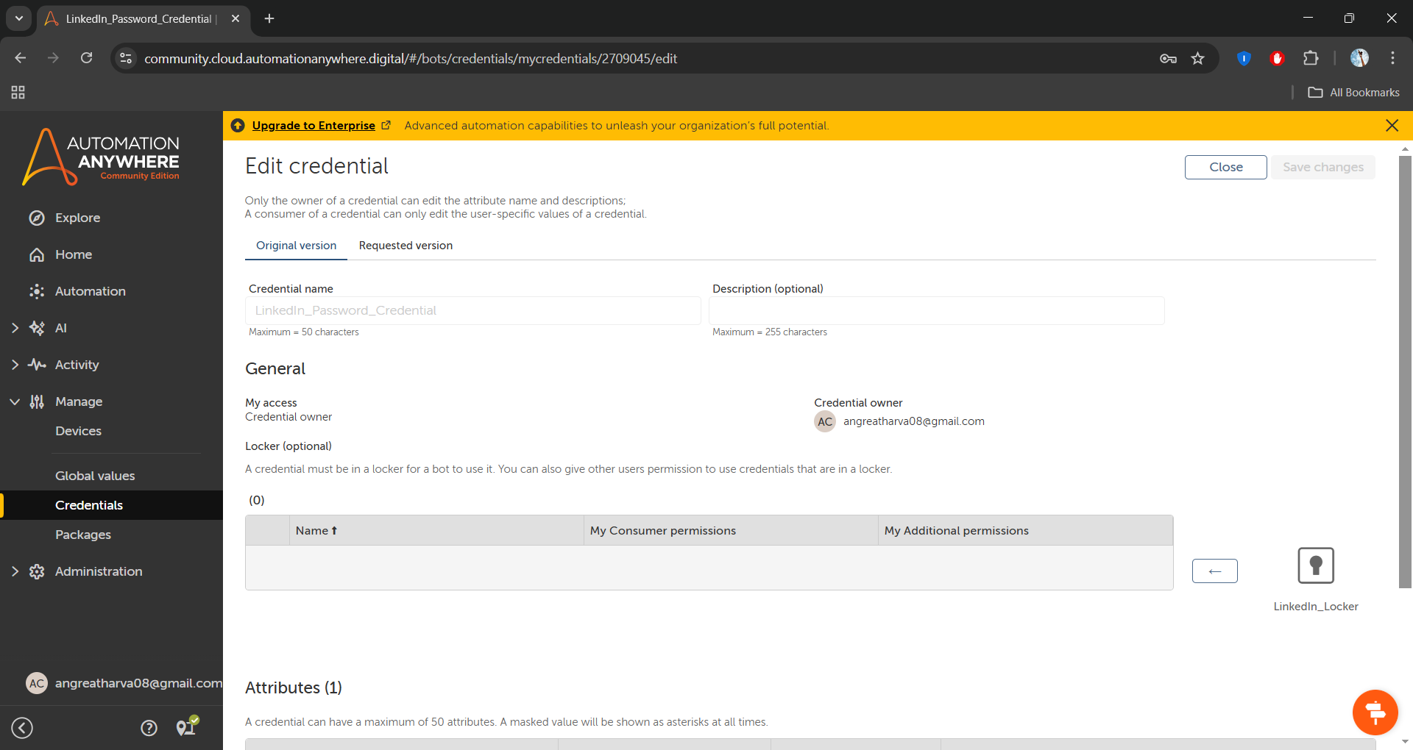

1. Now create a Linkedln_Locker

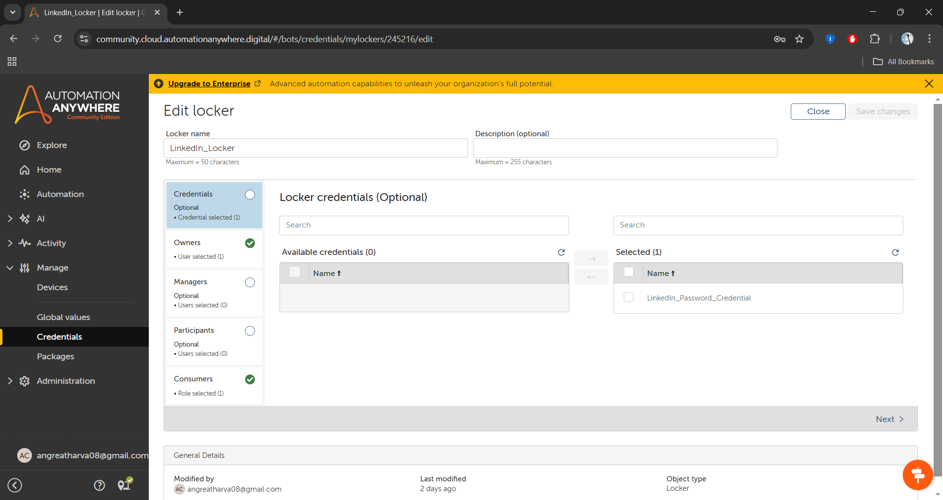

1. Now add this locker credential in your password properties

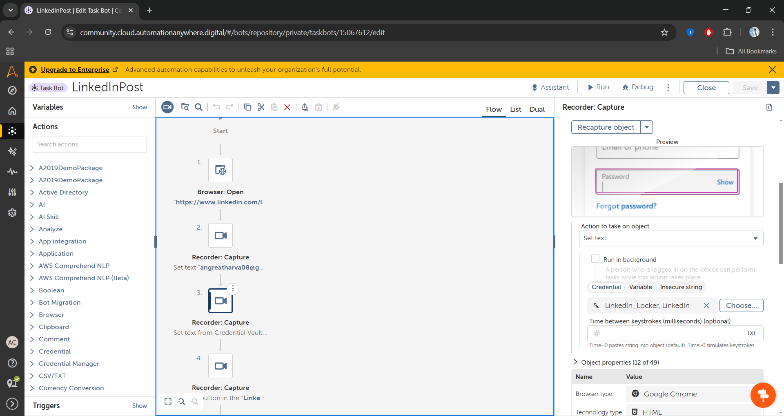

1. Now add the recorder capture to capture sign-in option

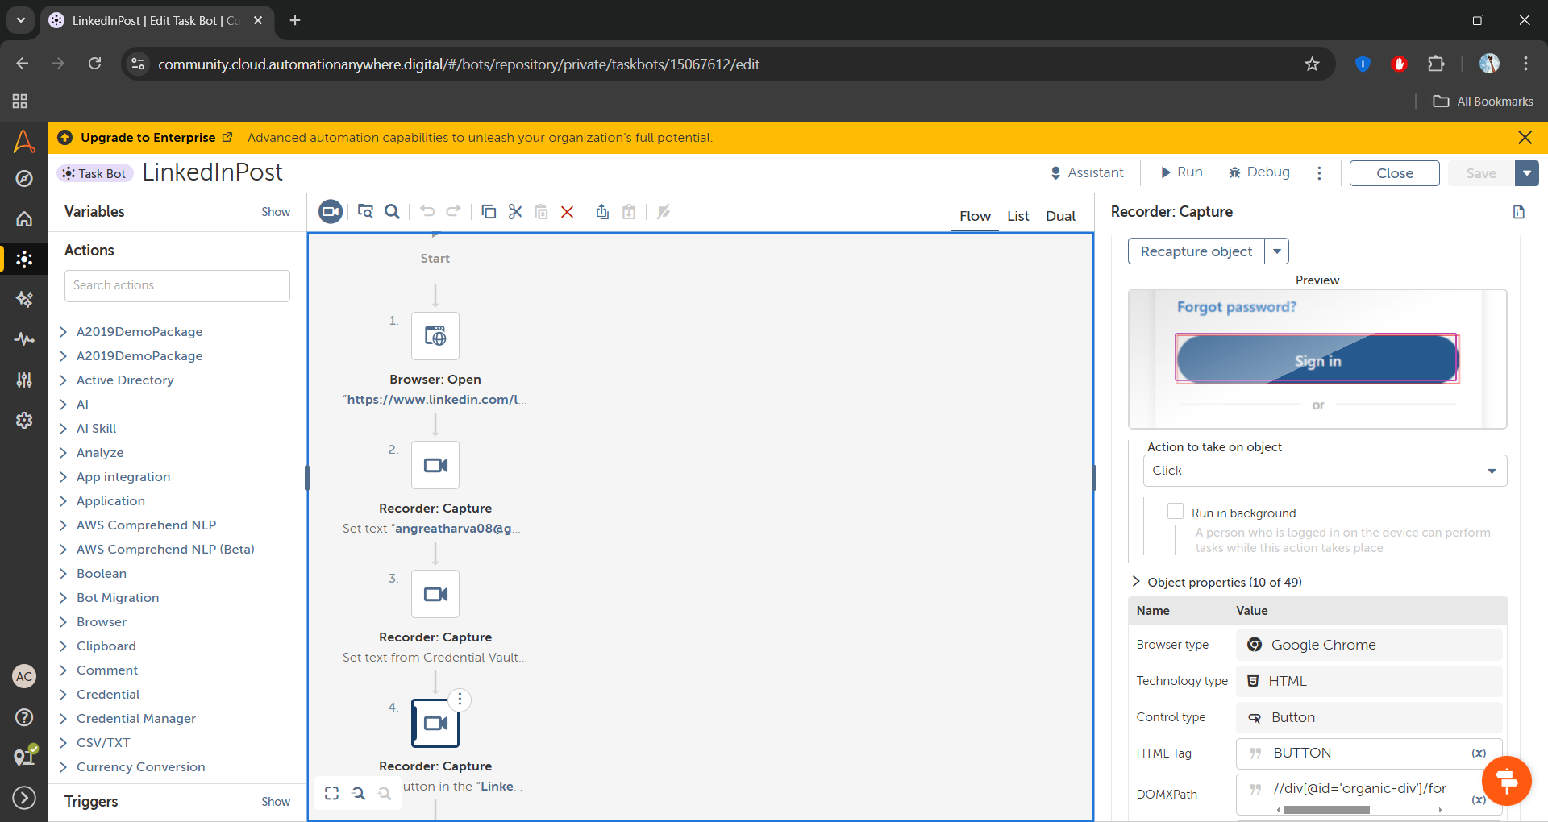

1. Next add the reorder capture action to capture the add a post bot and set action to click

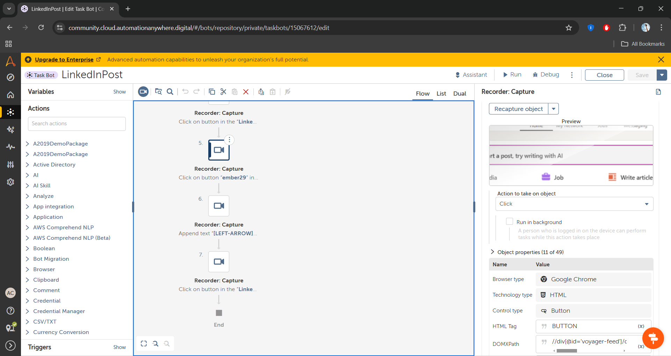

1. Now add the recorder capture action to capture the post field to and in action to perform click on append text add the text you want to add.

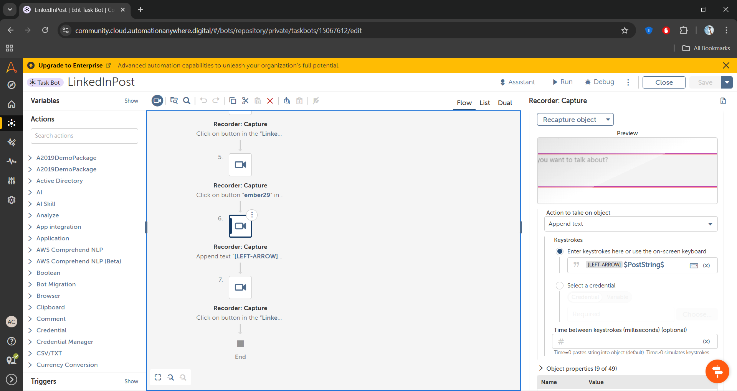

1. Again add the recorder capture action to capture that post button to create a post and in action to perform select click

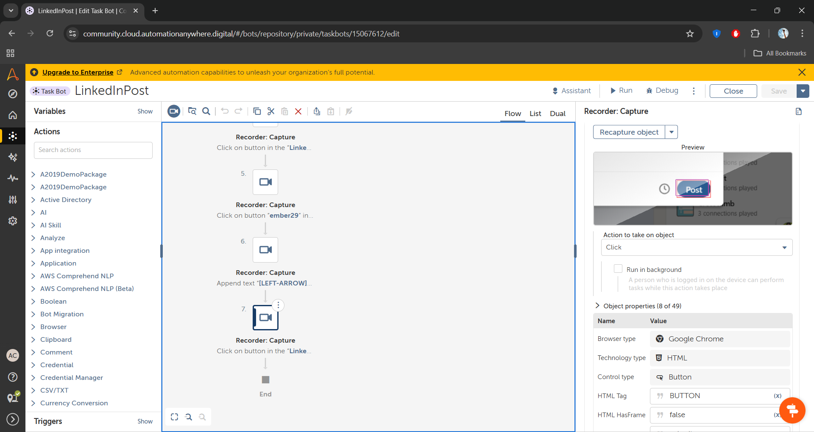

**Outputs:**

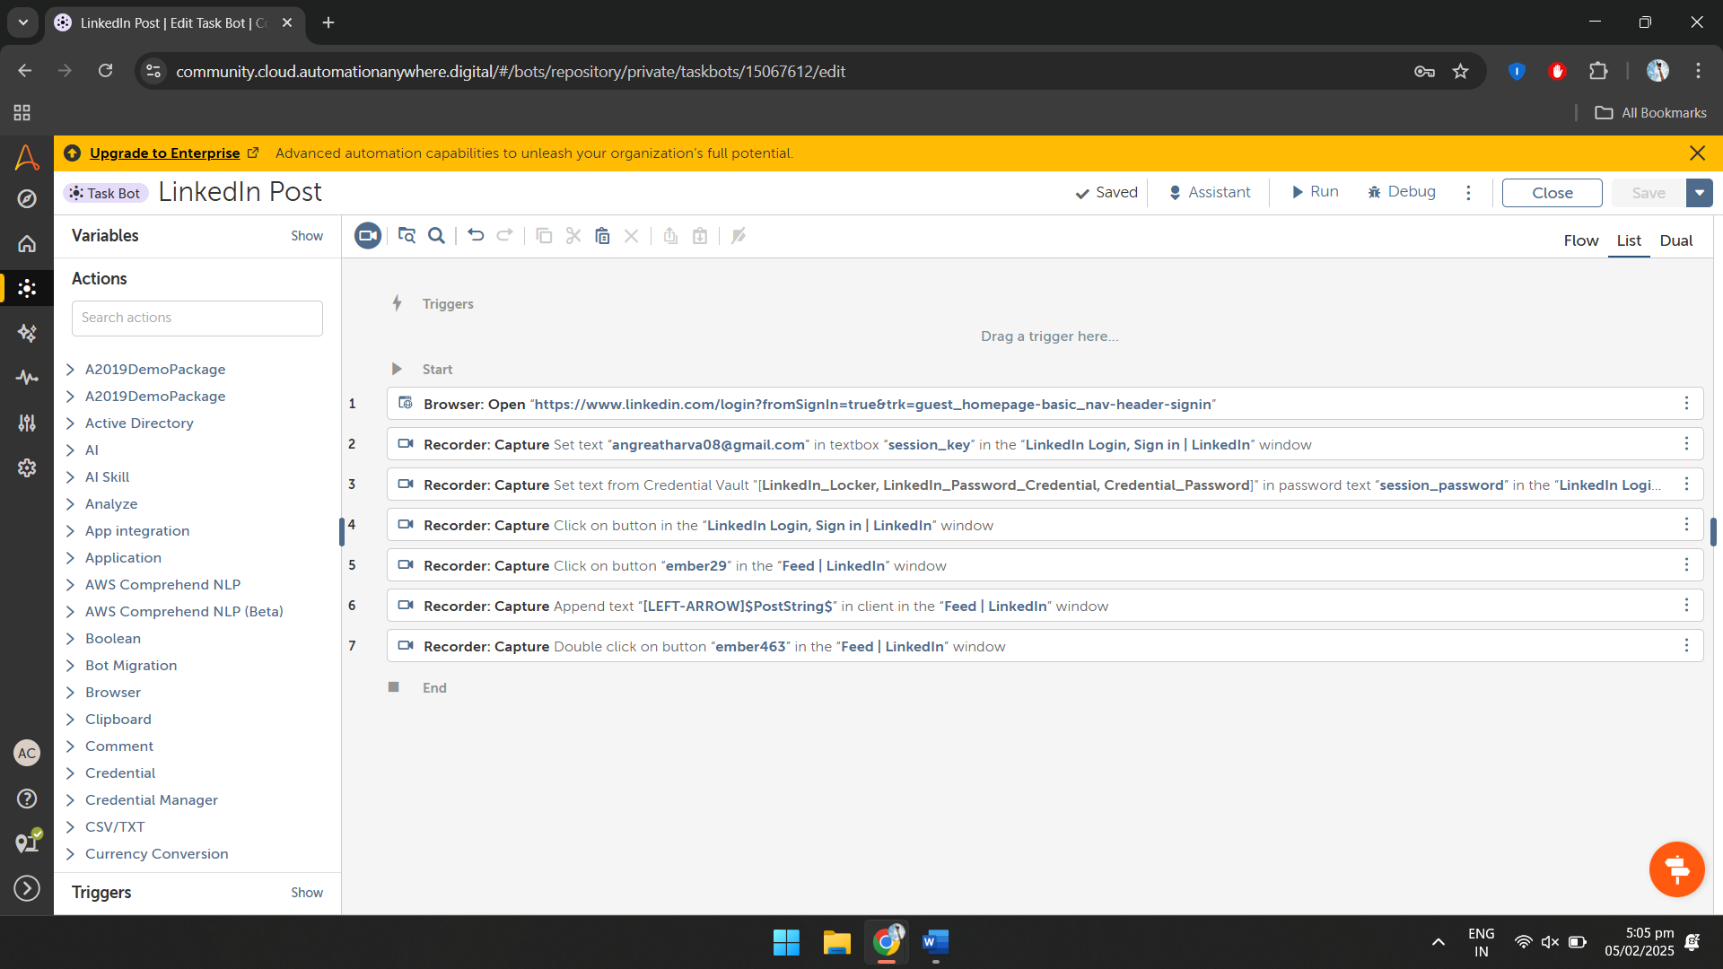

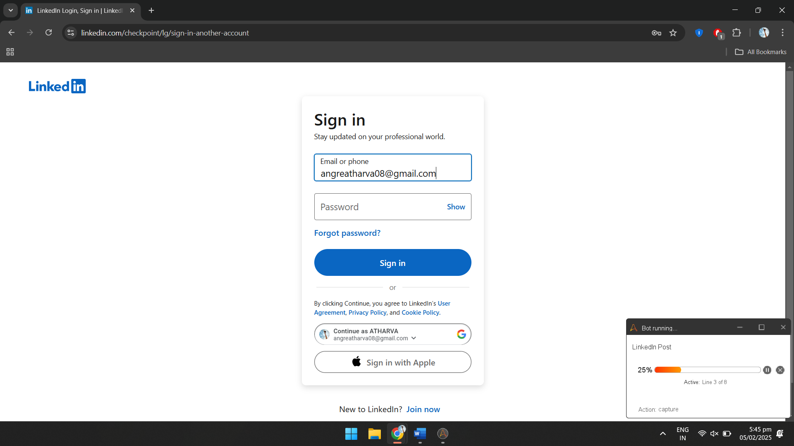

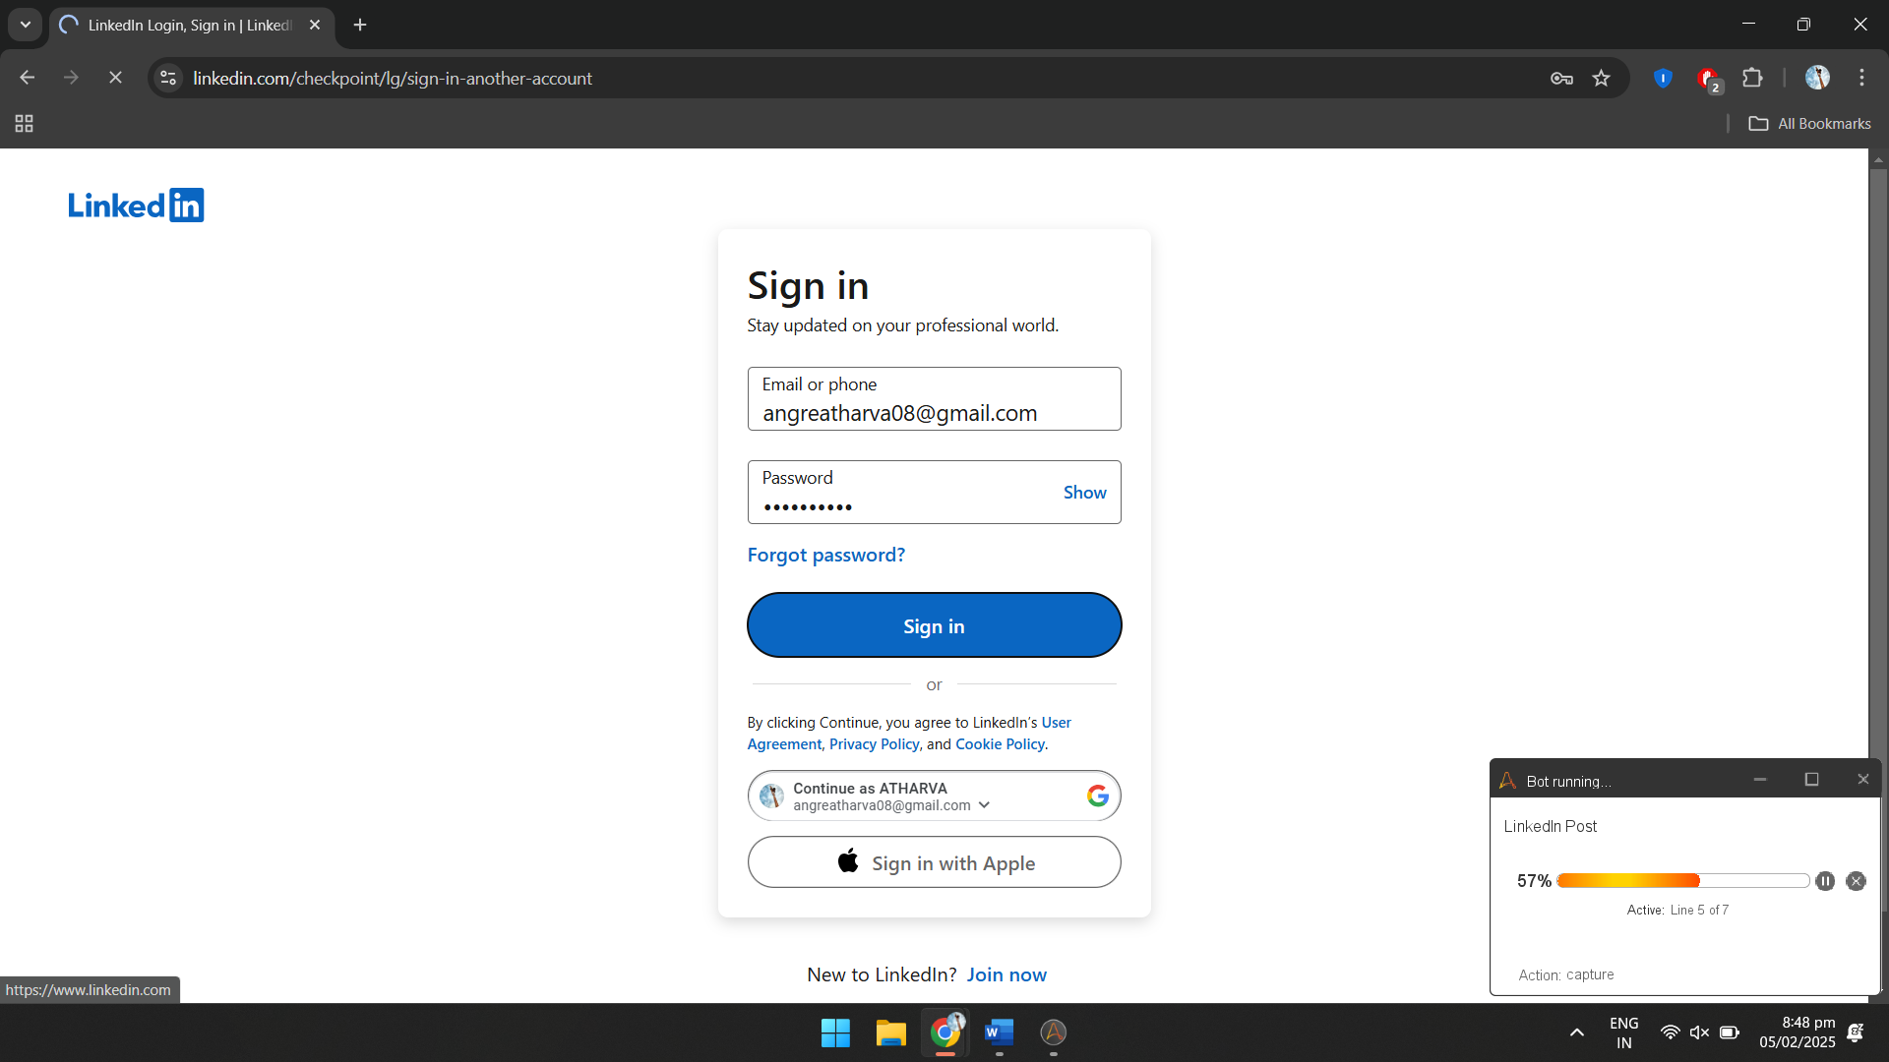

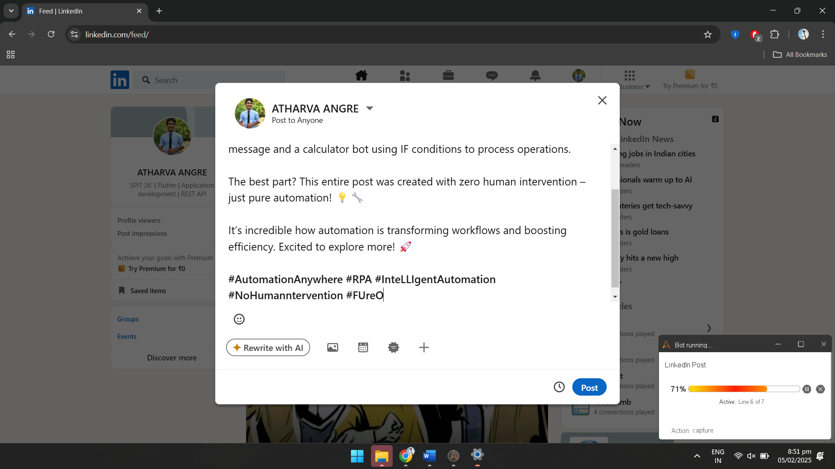

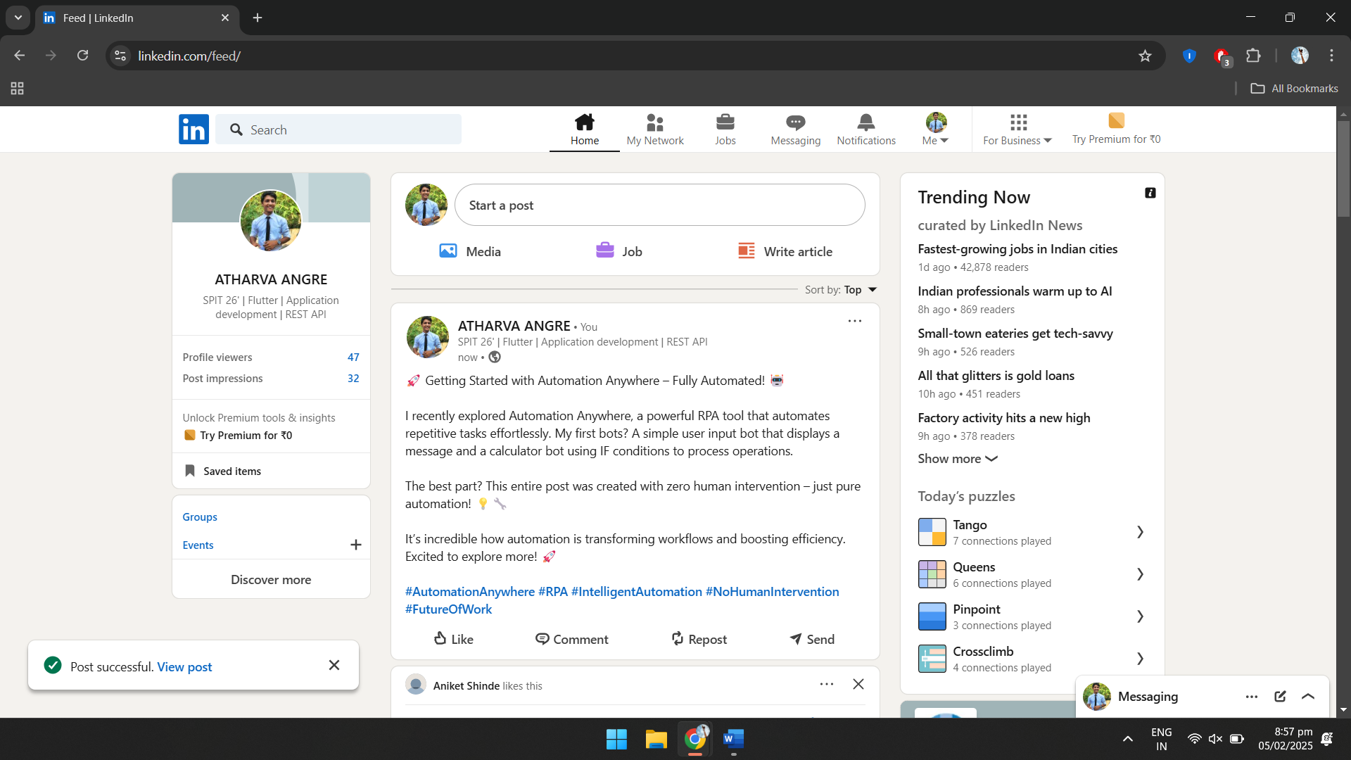

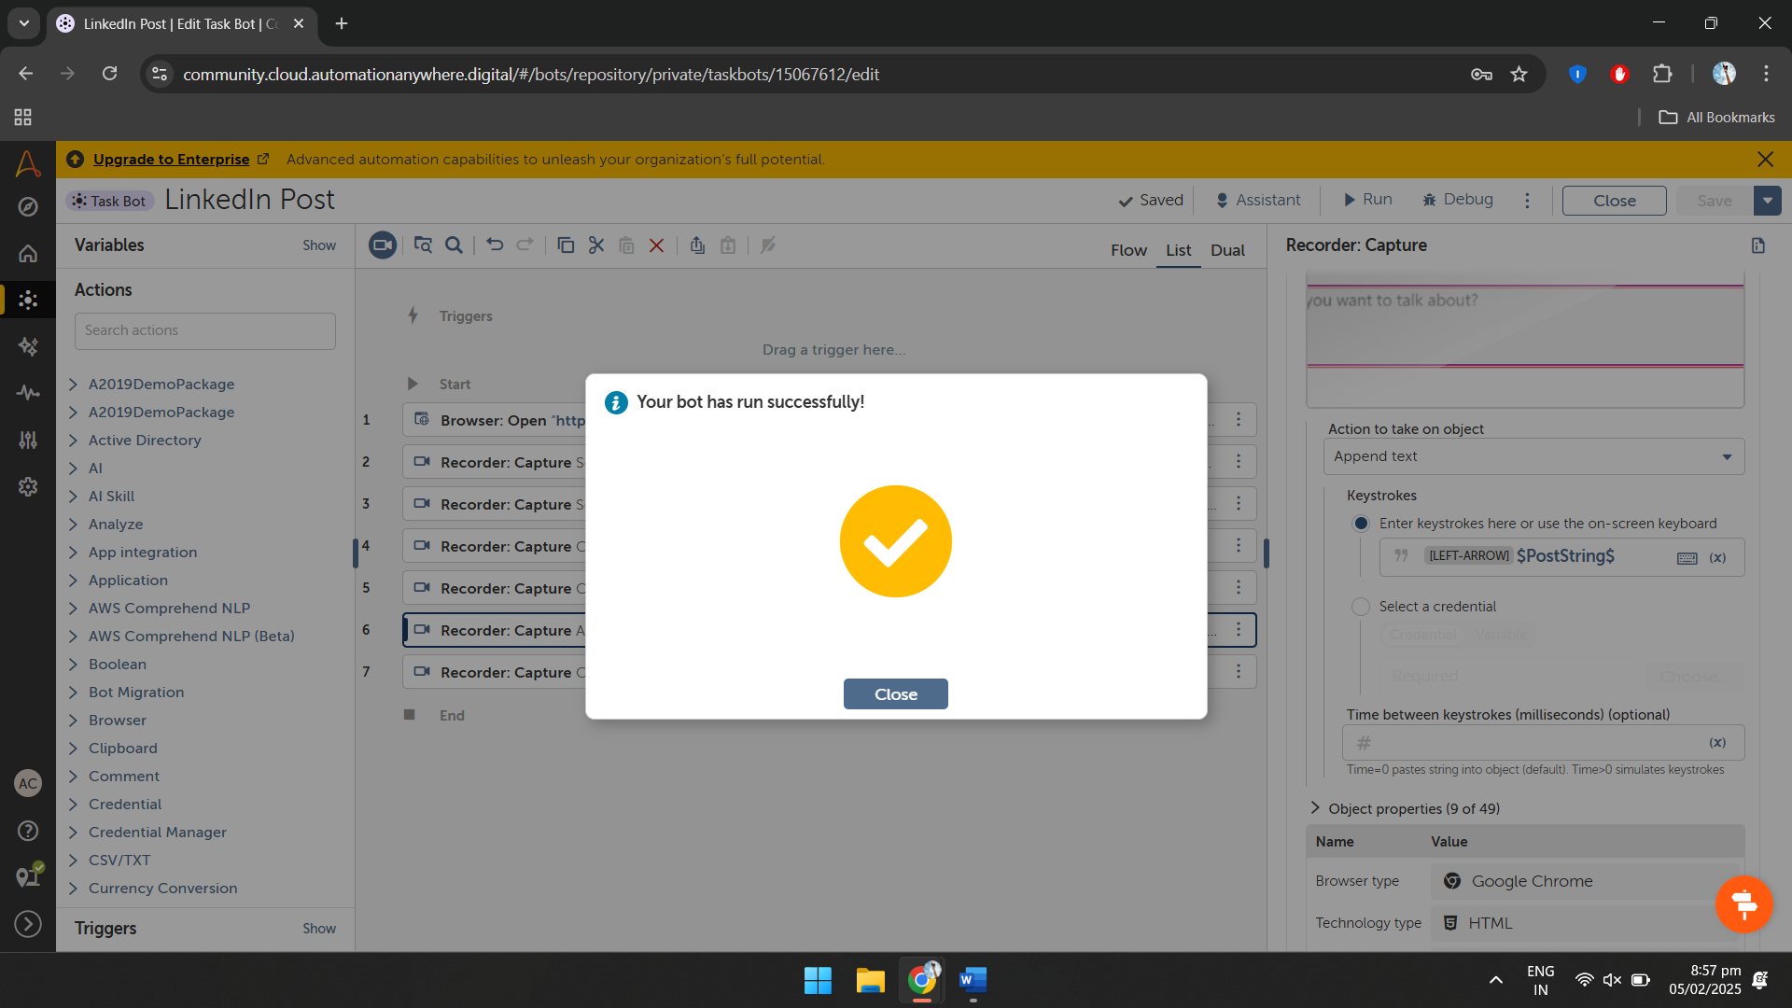

**Observation:**

The task involves automating the process of logging into LinkedIn and creating a post using Automation Anywhere. The bot, named LinkedlnPost, opens the LinkedIn sign-in page using the Browser Open action. The Recorder Capture action is used to enter the email and password, where the password is securely stored in Linkedln_Locker using credentials. The bot then captures and clicks the Sign In button. After logging in, it navigates to the post creation section, appends the desired text, and clicks the Post button to publish the content.